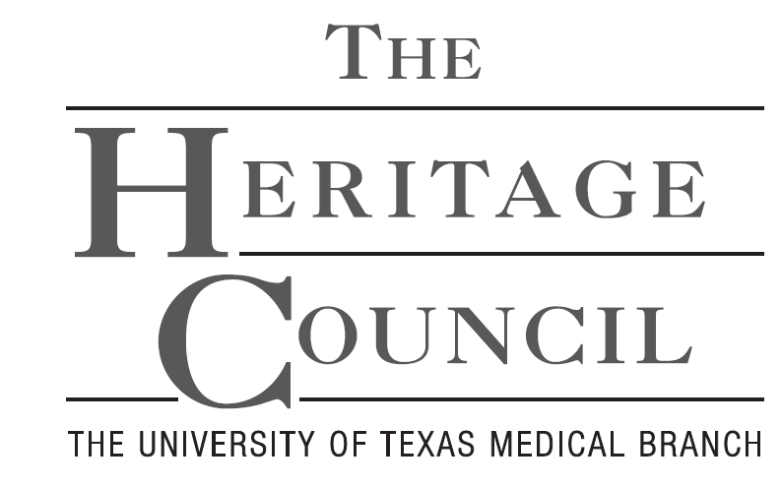
Gift and Estate Planning Intention Letter

New____ Revision/Update____

As evidence of my/our desire to provide a legacy of support to UTMB, I/we have named the Board of Regents of The University of Texas System for the benefit of The University of Texas Medical Branch at Galveston (“UTMB”) as a beneficiary of my/our estate plans.

Name(s):
Address: | Phone:
City, State, Zip: | Email:
My/Our gift is designated for the following purpose:

Estimated value of gift: $________________

Type of Gift: (Check applicable box below)
 | Bequest (Will) |  | Life Insurance Beneficiary
 | Retirement Account Beneficiary |  | Charitable Gift Annuity
 | Financial Account Beneficiary |  | Other:

Heritage Council and Gift Recognition:
 | You may publish my name as a UTMB Heritage Council Member to encourage others to contribute.
 | Name(s) to be listed for recognition:
 | Please treat this gift as anonymous. |  | Please treat all gifts to UTMB as anonymous.

Reporting Succession Plan: (Contact information for individuals who should receive reports and/or event notifications after your lifetime) *
Name(s): | Relationship:
Address: | Phone:
City, State, Zip: | Email:
Notes:
*continue on additional page if necessary

Signature Date

Signature Date

As with any decision involving your assets, we urge you to seek the advice of your professional counsel
when considering a gift to The University of Texas Medical Branch at Galveston.

Donors retain the right to change or revoke revocable gift plans; however, we request that you notify UTMB should
your intent toward UTMB change or the value of your estate’s potential donation significantly increase or decrease.

THANK YOU FOR YOUR GENEROUS SUPPORT OF UTMB

UTMB Development Office * Gift and Estate Planning * 301 University Boulevard * Galveston, TX 77555-0148 * 409.772.8767* mylegacy.utmb.edu

